PROJECT REPORT

On

**Online Food Ordering**

SUBMITTED IN PARTIAL FULFILLMENT OF THE REQUIREMENTS

FOR THE AWARD OF THE DEGREE OF

BACHELOR OF ENGINEERING

INFORMATION TECHNOLOGY

SUBMITTED BY

TEIT41 Prajakta Mandekar

TEIT66 Pallavi Vanjari

TEIT72 Piyush Kharat

UNDER THE GUIDANCE OF

Prof. Aditi Das

 

DEPARTMENT OF INFORMATION TECHNOLOGY

Nutan Maharashtra Institute of Engineering & Technology

Talegoan-Dabhade, Pune - 410 507

YEAR 2020-21

AFFILIATED TO

 

Savitribai Phule Pune University

**Savitribai Phule Pune University**

PCET’s Nutan Maharashtra Institute of Engineering and Technology,

Talegoan-Dabhade, Pune - 410 507



DEPARTMENT OF INFORMATION TECHNOLOGY

C E R T I F I C A T E

This is to certify that the project report entitled,

**Online food ordering system**

Submitted by

**Mr. Piyush Kharat, Ms. Prajakta Mandekar, Ms. Pallavi Vanjari**

is a bonafide work carried out by them under the supervision of Prof. Aditi Das

and it is submitted towards the partial fulfillment of the requirement of Savitribai Phule Pune University, Pune for the award of Bachelor of Engineering.

|  |  |
| --- | --- |
| Prof. Aditi Das | External Examiner |
| (Subject Teacher) |  |
|  |  |
| Prof. Nitin Dhawas | Dr. Lalit Kumar Wadhwa |
| (Head of Department) | (Principal) |
|  |  |

Acknowledgement

This is to acknowledge and thank all the individuals who played an important role in shaping this report. Without their constant support, guidance and assistance this report would not have been completed. Without their co-ordination, guidance and reviewing this task could not be completed alone.

I avail this opportunity to express my deep sense of gratitude and wholehearted thanks to my guide **Prof. Aditi Das** for giving her valuable guidance, inspiration and encouragement to embark this report.

This report being conceptual one needed a lot of support from my guide so that I could achieve what I was set out to get. I also take great pleasure in thanking and providing appropriate guidance. I would personally like to thank **Prof. Nitin** **Dhawas**, Head of IT Dept. At Pimpri Chinchwad Education Trust’s NutanMaharashtra Institute of Engineering Technology (NMIET), and our honorable principal Dr. **Lalit Kumar Wadhwa** **Sir** who creates a healthy environment for all of us to learn in best possible way.

Last but not least I am grateful to our parents for all their support and encouragement.

**Ms. Prajakta Mandekar(41)**

**Ms. Pallavi Vanjari(66)**

**Mr. Piyush Kharat(72)**

**Abstract**

Generally, Online food ordering management system is a software used to ease the customer’s life. Sometimes you don’t feel like cooking or you are not in the mood to visit the restaurants as well, therefore we here propose an Online Food Ordering Management System which can help the customers to get food delivered immediately. This is mostly designed for a single restaurant having various food items at valuable food price. It gives effective way to order your food and almost within no time food will be delivered. Customer, he/she has login form with password in order to secure the information details and then they can select his/her favorite food items, place the order, also mention the quantity and finally can make the payment. When the order is placed, it gets stored in the database of the restaurants and then the staffs go through the orders and processes it efficiently.

Keywords: Hypertext Preprocessor (PHP), Hypertext Markup Language (HTML), Cascading Style Sheets(CSS),Bootstrap.

**Contents**

|  |  |  |
| --- | --- | --- |
|  |  |  |
| 1. | **SYNOPSIS………………………………………………**  1.1. Project Title  1.2. Problem Statement, Solving Approach and Efficiency issues  1.3. Problem Statement  1.4. Solving Approach  1.5. Efficiency issues  1.6. Outcomes | 1 |
| 2. | **INTRODUCTION…………………………………….**  2.1. Background.  2.2. Motivation  2.3. Objective  2.4. Goals | 3 |
| 3. | **OVERVIEW……………………………………………….**  3.1. Background  3.2. Related Work | 5 |
| 4. | **REQUIREMENTS SOFTWARE SPECIFICATION…..**  4.1. Introduction  4.1.1. Purpose and Scope of Document  4.1.2. Implementation Constraints  4.1.3. Assumptions and Dependencies  4.2. System Features  4.2.1. Technical Feasibility  4.2.2. Economic Feasibility  4.2.3. Performance Feasibility  4.2.4. Software Interfaces | 7 |
| 5. | SOFTWARE DESIGN SPECIFICATION………………...  5.1. Introduction  5.2. Behavioral Model and Description  5.3. Technical Specification | 8 |
| 6. | **TEST SPECIFICATIONS…………………………………**  6.1. Introduction  6.2. Test Planning  6.3. Testing Strategy | 11 |
| 7. | **Results and Discussions…………………………………….**  7.1. Screenshots  7.2. Conclusion | 14 |
| 8. | **REFERENCES……………………………………………...** | 17 |

**List of Figures**

4.1 Use Case Diagram . . . . . . . . . . . . . . . . . . . . . . . . . . . . . . . . . . . . .10

4.2 Class Diagram . . . . . . . . . . . . . . . . . . . . . . . . . . . . . . . . . . . . . . . .11

4.3 E-R Diagram . . . . . . . . . . . . . . . . . . . . . . . . . . . . . . . . . . . . . . . . 12

5.1 Activity Diagram . . . . . . . . . . . . . . . . . . . . . . . . . . . . . . . . . . . .. 17

5.2 Sequence Diagram . . . . . . . . . . . . . . . . . . . . . . . . . . . . . . . . .. ... 18

7.1 Home Page . . . . . .. ... . .. . . . . . . . . . . . . . . . . . . . . . . . . . . . . . . .33

7.2 Member registration page . . . . . . . . . . . . . . . . . . . . . . . . . . . . . .33

7.3Admin login page. . . . . . . . . . . . . . . . . . . . . . . . . . . . . . . .. . . . . . .34

7.4Member login page . . . . . . . . . . . . . . . . . . . . . . . . . . . . . . . . . .. . 34

7.5Admin dashboard . . . . . . . . . . . . . . . . . . . . . . . . . . . . . . . . . .. . . .35

7.6Member dashboard. . . . . . . . . . . . . . . . . . . . . . . . . . . . . . . . . .. . . 35

7.7Add notice. . . . . . . . . . . . . . . . . . . . . . . . . . . . . . . . . .. . . . . . . . . .36

7.8Member details. . . . . . . . . . . . . . . . . . . . . . . . . . . . . . . . . .. . . . . .36

7.9Feedbak report. . . . . . . . . . . . . . . . . . . . . . . . . . . . . . . . . .. . . . . . 37

7.10Maintenance report. . . . . . . . . . . . . . . . . . . . . . . . . . . . . . . . . .. . 37

7.11Update profile by member. . . . . . . . . . . . . . . . . . . . . . . . . . . . . . 38

7.12Member feedback page. .. . . . . . . . . . . . . . . . . . . . . . . . . . . . . . . .39

7.13Member maintenance page . . . . . . . . . . . . . . . . . . . . . . . . . . . . . .39

7.14Member table. . . . . . . . . . . . . . . . . . . . . . . . . . . . . . . . . .. . . . . . .40

7.15Maintenance table. . . . . . . . . . . . . . . . . . . . . . . . . . . . . . . .. . .. . .40

7.16Feedback table. . . . . . . . . . . . . . . . . . . . . . . . . . . . . . . . . .. . . . . . 41

7.17Event table. . . . . . . . . . . . . . . . . . . . . . . . . . . . . . . . . .. . . . . . . . ...41

7.18Notice table. . . . . . . . . . . . . . . . . . . . . . . . . . . . . . . . . .. . . . . . . .. 42

**Chapter 1**

**SYNOPSIS**

**1.1 Project Title:**

ONLINE FOOD ORDERING

**1.2 Problem Statement, Solving Approach and Efficiency issues: -**

1.2.1 Problem Statement

Many restaurants are storing all of their data in manual way. They have huge numbers of customers daily. So because large number of customer, they need the help of some features so they can store and maintain the data accurately. For manager it is difficult to view the table, orders, kitchen, reception and the counter simultaneously.

They need full-fledged software to maintain their day to day transaction orders and also regular update on records cash transaction, daily staffs reports customers feedbacks etc. in the existing system entering all the details are done manually, it is taking lots of time and there is no chance for mistakes.

1.2.2Solving Approach

This system helps to keep all the data in one database and the access to each and everything is easy.

1.2.3Efficiency issues

* This system easily allows members to register, quick maintenance payment, online feedback system.
* Quick access to admin to look after each and every detail.

1.3 Outcomes

This system improves the method of taking the order from customer. The online food ordering system sets up a food menu online and customer can easily place the orders as per their wish. Also with a food menu, customers can easily track the orders.

It helps customer in making order easily; It gives information needed in making order to customer. Also, with a food menu online, tracking the orders is done easily, it maintain customer's database and improve the food delivery service.

**Chapter 2**

**INTRODUCTION**

**2.1 Background**

This proposal is written to propose an efficient food order system to

enhance and improve the existing traditional food order management system and provide convenience, availability and integrity to restaurants**.**

For those restaurants which are using traditional method for food ordering processes, this

is a problem that can’t be eliminated. Because the entire manual process which involve

Waiters, pen and paper. Each food order transaction is noted down on a piece of

paper and the waiters pass the food order ticket to the kitchen for further processing.

While the food order tickets have passed to the kitchen, the sequence of the food order ticket might be interchanged with other ticket. Therefore, it will cause the restaurant not be able to serve their customers in sequentially according to the customer order sequence

especially in peak hour, so customers would complaint to the restaurant in turn it will

affect the customer relationship of the restaurant.

**2.2 Motivation**

The motivation for designing this application came because my family is involved in the fastfood business and I personally do not like waiting for long in the store or to have to call store to place an order especially during the peak lunch or dinner hours. Moreover, I value recent learning about the Java and JSP Programming languages as well as seeing how powerful and dynamic they are when it comes to web designing and applications. The languages used to build this application are JavaScript, JSP, HTML and Java at client facing whereas Oracle database at the backend because I found them to be extremely useful while working on the technologies.

**2.3 Objective**

Our project will enable a customer to order different kinds of cuisines from their favorite restaurant. They will be able to enjoy the subtle taste of their favorite food just within a matter of time with the help of this website.

In addition, this website will allow the customers to go through the whole restaurant menu at once and choose their particular type of food item and check their prices and can order at their own convenience. In case they are ordering for more than themselves they will be able to set the quantity of food as well.

**2.4 Goals**

* This project will serve only the following:
* All the courses’ textbooks and references by semester.
* Buyers and seller can conduct a predetermined process.
* Privileges to site administrator to maintain the website.
* Privileges to Marketing supervisor to publish the promotion and announcement.



**Chapter 3**

**OVERVIEW**

**3.1 Background**

Food is an important part of human life. No one in this world can live without food. The main approach is to insert, update, delete items and preserving the integrity of data as well as the privacy of the customer as well as the admin.

* To get the current status of ads posted per day.
* Maintain database of restaurant in a proper format.
* The customer can be registered, updated and deleted as well.

**3.2 Related Work**

The system implementation is in PHP and Html, including login validation, registration, as well as other manipulation operations such as insert, update, delete and display. The back end is used is MySQL. The connectivity is done of PHP and MySQL. The integrity of data is preserved by using this application. It preserves time of the employee working in canteen.

* Registration details
* Insert data of customers.
* Update data of customers.
* Delete data of customers.
* Logout

**Chapter 4**

**REQUIREMENT SOFTWARE SPECIFICATION**

**4.1 Introduction**

**4.1.1 Purpose and Scope of Document**

The Scope Statement is distributed to all the project stakeholders for their approval. It is the description of the project, including the objectives, planned deliverables, and requirements. It becomes the baseline document that can only be changed through the process outline the society management.

**4.1.2 Design and Implementation Constraints**

* System must have PHP Technology.
* System requires XAMPP Server, MySQL installed on the server system which is very vital to maintain integrity of database.

**4.1.3 SOFTWARE REQIUREMENTS**

**Below mentioned are the modules we have used in our project Online food ordering system,**

• **HTML (Hypertext Markup Language)** is the most basic building block of the Web. It defines the meaning and structure of web content. Each page contains a series of connections to other pages called hyperlinks. Every web page you see on the Internet is written using one version of HTML code or another.

• **Cascading Style Sheets (CSS)** is a simple mechanism for adding styles (e.g., fonts, colors, spacing) to Web documents. CSS defines how HTML elements are to be presented on screen, paper, or in other media. CSS saves a lot of work. It can control the layout of multiple web pages all at once.

**PHP** is a server-side scripting language. that is used to develop Static websites or Dynamic websites or Web applications. PHP stands for Hypertext Preprocessor, which earlier stood for Personal Home Pages. PHP scripts can only be interpreted on a server that has PHP installed. As mentioned above HTML CSS and PHP are the languages used in this project.

MySQL database and PHP programming language.

**The database language used in our project,**

**MySQL**: MySQL is a relational database management system based on SQL – Structured Query Language. The most common use for MySQL, however, is for the purpose of a web database. Standard SQL commands such as ADD, DROP, INSERT and UPDATE can be used in MYSQL.

**4.2 System Features**

**4.2.1 Technical Feasibility**

The system must be evaluated from the technical point of view first. The assessment of this feasibility must be based on outline design of the system requirement in the terms of input, output, procedure. Having identified an outline of system, the investigation must go on to suggest the type of equipment, required method developing the system, of running the system once it has been designed. The project should be developed such that the necessary functions and performance are achieved within the constraints. The project is developed within latest technology. So, there are minimal constraints involved with this project. The system has been developed using HTML, CSS, PHP, MySQL technologies and project is technically feasible for development.

**4.2.2 Economic Feasibility**

Economic feasibility looks at the financial aspects of the project. Economic feasibility concerns with the returns from the investments in the project. It determines whether it is worthwhile to invest the money in the proposed system. It is not worthwhile spending a lot of project for no result. To carry out an economic feasibility for a system, it is necessary to place actual money value against any purchases or activities needed to implement the project.

**4.2.3 Performance Feasibility**

The system provides a user-friendly graphical interface and is therefore easy to use. User who knows the basic of computer i.e., how to operate the computer easily use this system.

**4.2.4 Software Interfaces**

Database: MySQL

Scripting Language: HTML, CSS, PHP, JavaScript, Bootstrap.

Front End: PHP

**4.2.5 Communication 4 Interfaces**

XAMPP Server, MySQL client-server

**4.3 Software Quality Attributes**

* **Availability:** The system shall be available if operations are performed on application.
* **Updatability:** The system shall allow addition and deletion of less based on access rights provided.
* **Reliability:** Integrity of information maintained and supplied to the system and availability of components.
* **Testability:** New modules designed to be added to system must be tested to check whether they are integrated properly and compatible with input-output format of the system.
* **Usability:** The system does not need much learning. Documentation provided for the system will include user manuals, developer reference and common FAQ.

**Database Requirements**

**MySQL**

MySQL is a fast, easy-to-use RDBMS being used for many small and big businesses. MySQL is developed, marketed and supported by MySQL AB, which is a Swedish company. MySQL is becoming so popular because of many good reasons.

•MySQL is released under an open-source license. So, you have nothing to pay to use it.

•MySQL is a very powerful program. It handles a large subset of the functionality of the most expensive and powerful database packages.

•MySQL uses a standard form of the well-known SQL data language.

•MySQL works on many operating systems and with many languages including PHP, PERL, C, C++, JAVA, etc.

•MySQL works very quickly and works well even with large data sets.

•MySQL is very friendly to PHP, the most appreciated language for web development.

•MySQL supports large databases, up to 50 million rows or more in a table. The default file size limit for a table is 4GB, but you can increase this (if your operating system can handle it) to a theoretical limit of 8 million terabytes (TB).

•MySQL is customizable. The open-source GPL license allows programmers to modify the MySQL software to fit their own specific environments.

**4.4 Usage scenario**

**4.4.1 Use Case Diagram:**

Use case diagrams are used to gather the requirements of a system including internal and external influences. These requirements are mostly design requirements. So, when a system is analyzed to gather its functionalities use cases are prepared and actors are identified. Main Actors in our system are:

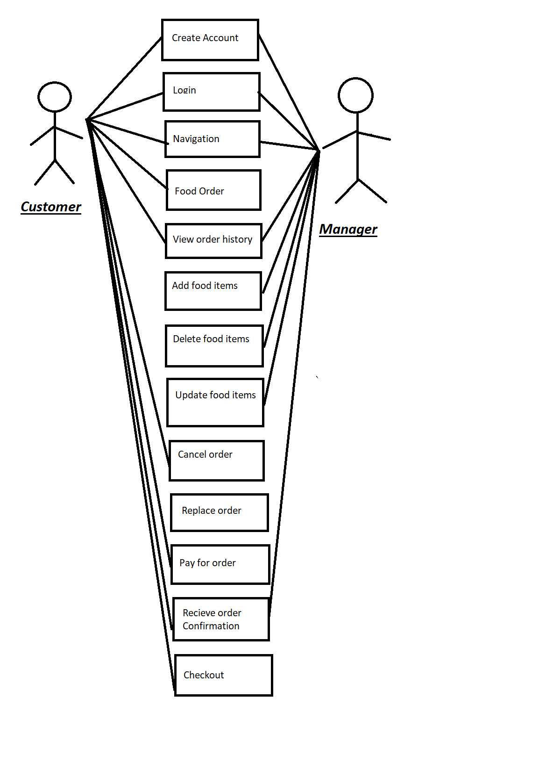

**4.4.2 Class Diagram**

The purpose of the class diagram is to model the static view of an application. The class diagrams are the only diagrams which can be directly mapped with object-oriented languages and thus widely used at the time of construction.

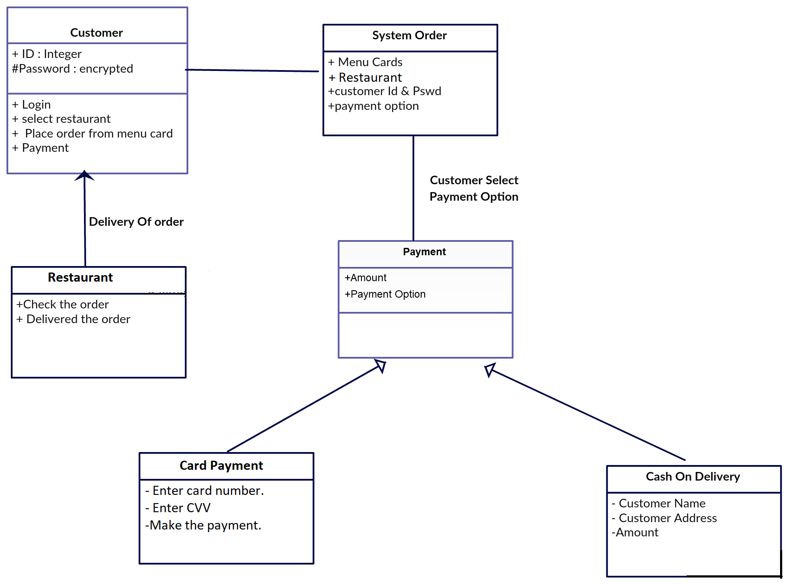

The entity-relationship

**4.4.3 Entity Relationship Diagram**

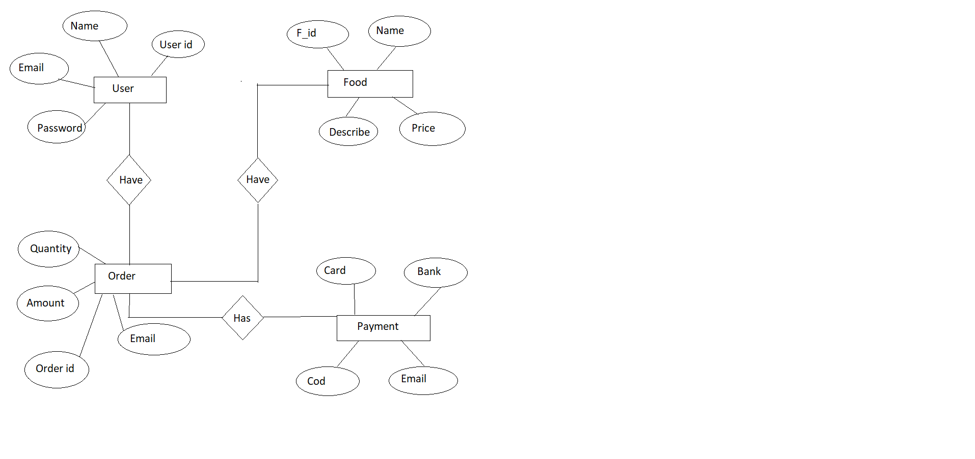

**Chapter 5**

**SOFTWARE DESIGN SPECIFICATION**

**5.1 Introduction**

**5.1.1 Goals and objectives**

**Objective:**

* All the courses’ textbooks and references by semester.
* Buyers and seller can conduct a predetermined process.
* Privileges to site administrator to maintain the website.
* Privileges to Marketing supervisor to publish the promotion and announcement.

**Goals:**

The prime goal of this research is making human life smarter and easier using this system. This research saves time and overhead of manager. With this misconception and fault in calculation can be avoided.

**5.2 Behavioral Model and Description**

**5.2.1 Description for software behavior**

This system is proposed to aim reliable storage in database while achieving integrity. Its main goal is to enable authentication and viewing data from the database on screen.

**5.2.2 Society Management**

**5.2.3 Modules**

* User
* Admin
* Maintenance
* Feedback
* Notice

>**Purpose and Scope of Document**

The Scope Statement is distributed to all the project stakeholders for their approval. It documents a description of the project, including the objectives, planned deliverables, and requirements.

**5.2. Behavioral Model and Description**

**5.2.1** **Behavioral Model and Description for software behavior**

This system is proposed to aim reliable storage in database while achieving integrity. Its main goal is to enable authentication and viewing data from the database on screen.

**5.2.2 System Architecture**

**5.2.3 Modules**

* User
* Admin
* Maintenance
* Feedback
* Notice

**5.2.4 USER:**

**USER REGISTRATION:**

In this module new user register the information in order to use the system.

**5.2.5** **LOGIN:**

* Registration details
* Insert data by user/admin.
* Update data by user/admin
* Delete data by admin.
* Logout

**REGISTRATION DETAILS:**

In this module the Admin can see the Member details.

**INSERT DATA OF Ad:**

In this module admin can insert the new entries of members in the database.

**UPDATE DATA OF Ad:**

In this module the admin can update the existing tuple in the database.

**DELETE DATA OF Ad:**

In this module the admin can delete the existing entry in the database.

**LOGOUT**

In this module admin logout from the system.

**5.3 Technical Specification**

**PHP**

* PHP stands for Hypertext Preprocessor.
* It is developed in 1994 by Apache group.
* PHP is server-side scripting language.
* It is mainly used for handling and database access.
* Simple
* Platform Compatibility
* Creation of logs.
* High Performance
* Robust
* Dynamic
* Secure PHP is general purpose scripting language that is especially suited to server-side web development in which case PHP generally runs on a website. Any PHP code in a requested is executed by the PHP run-time usually to create dynamic web page, content or dynamic images used on websites or elsewhere. It can also be used for command line scripting and client-side graphical user interface applications. PHP can be deployed on most web servers, many operating systems and platforms and can be used with many relational databases management system. Most web hosting provides us support for PHP for use by their clients. It is available free of charge and the PHP group provides the complete source code for users to build, customize and extend for their own use. PHP acts primarily as after, taking input from or stream containing text and PHP instructions and outputting another stream of data. Most commonly the output will be HTML, although it could JSON, XML or binary data such as image or audio formats. PHP includes various free and open-source libraries in its source distributions, or uses them in resulting PHP binary builds. PHP is fundamentally an Internet aware system with built in modules for accessing transfer protocol servers and many database servers. Numerous functions known to c programmers such as those in the studio family are available in standard PHP builds. PHP extensions can be complied statically into PHP or loaded dynamically at run-time. Features of PHP
* Platform-Independent PHP provides cross Platform compatibility unlike some other server-side scripting language.
* Creation of Logs The language contains access monitoring capabilities to create logs as the summary of recent accesses.
* Extensive Patten matching PHP supports extended regular expression that leads extensive pattern matching with remarkable speed.
* Dynamic PHP programming structure includes variable variables; that is the name of variable can be changed dynamically. Robust PHP is said to be robust in two ways.
* PHP is used dynamically and static.
* PHP provides exception.

5.4 Project design

5.4.1 Activity Diagram

Activity diagram is another important diagram in UML to describe dynamic aspects of the system. Activity diagram is basically a chart to represent the own

form one activity to another activity. The activity can be described as an operation of the system. So, the control own is drawn from one operation to another.

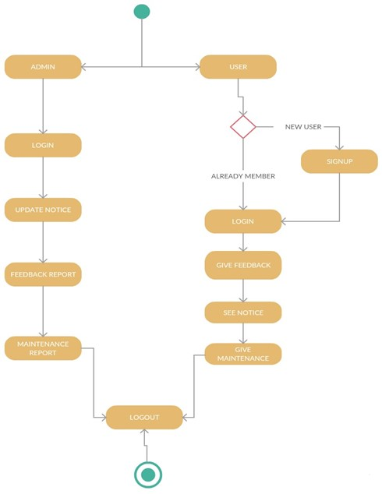

4.2 Sequence diagram

Sequence diagram describes an interaction by focusing on the sequence of messages that are exchanged, along with their corresponding occurrence specification on the lifelines.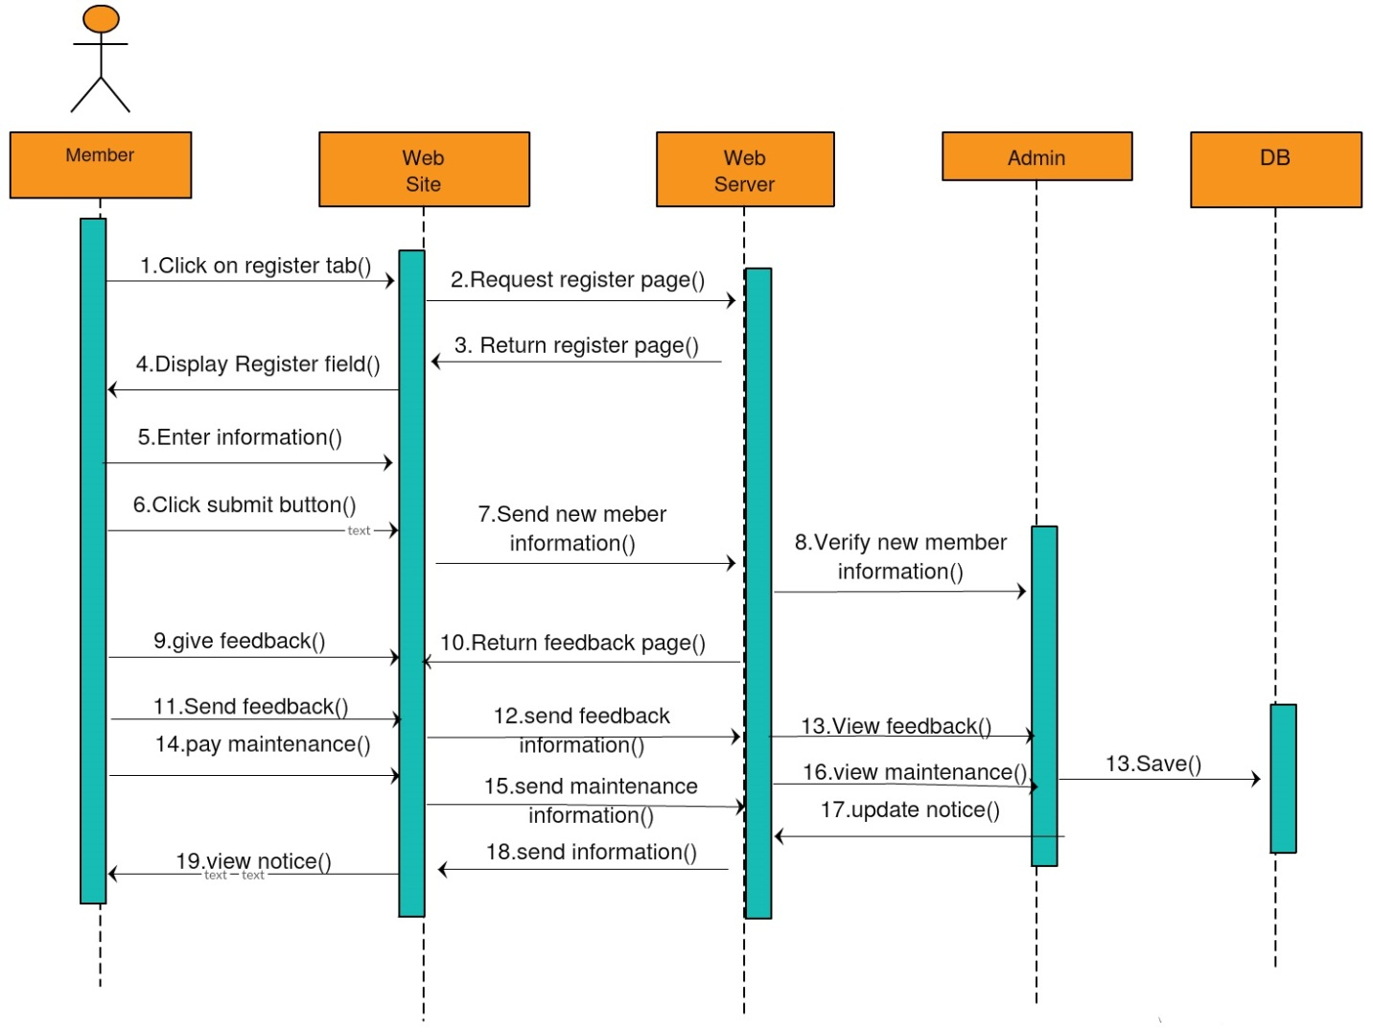

**Chapter 6**

**TEST SPECIFICATIONS**

**6.1 Introduction**

* Once source code has been generated, software must be tested to uncover as many errors as possible before delivery to the client.

Which is a very important to work the system successfully and achieve high quality of software. Testing includes designing a series of test cases that have a high likelihood of finding errors by applying software testing techniques.

* Software testing is a critical component of the software engineering process. It is an element of software quality assurance (SQA).
* System testing makes logical assumptions that if all the parts of the system are correct, the goal will be successfully achieved. The system should be checked logically. Validations and cross checks should be there. Avoid duplications of records that cause redundancy of data.

**6.2 Test Plan**

**Test Plan Identifier**: cost-sensitive it is used to identify test plan uniquely.

**1.** Purpose of the Test Plan Document The main purpose of this document is to a particular project’s needs. It documents and tracks the necessary information required to electively dine the approach to be used in the testing of the project as product. The Test Plan document is created during the Planning Phase of the project. Its intended audience is the project manager, project team, and testing team.

* Objective of Test Panning to and as many defects as possible and get them.
* Items to be Tested OR Not to be Tested Describe the items/features/functions to be tested that are within the scope of this test plan. Include a description of how they will be tested, when, by whom, and to what quality standards. Also include a description of those items agreed not to be tested.
* Items to be tested.
* Overall functionality of the application.
* User Interface of the application.

Not to be tested

• Performance of the application.

**5.**Test Approach Describe the overall testing approach to be used to test the projects product. Pro- vides an outline of any planned tests. There are many approaches like:

* Black Box Testing White Box Testing Here we used Black Box Testing approach. In Black Box Testing we just give input to the system and check its output without checking how system processes it.

**6.** Test Pass OR Test Fail Criteria When actual and expected results are same then test will be passed. When actual and expected results are different then test will be failed.

**7.**Test Entry OR Exit Criteria describe the entry and exit criteria used to start testing and determine when to stop testing.

* **Entry criteria:** As soon as we have requirement, we can start testing.
* **Exit criteria:** When bug rate falls below certain level we can stop testing.

**8.** Suspension OR Resumption Criteria describe the suspension criteria that may be used to suspend all or portions of testing. Also describe the resumption criteria that may be used to resume testing. Suspension criteria: If there is large change in application like change in re- requirements, we can suspend work for some time. Resumption criteria: After resolving the respective problem we can resume work.

**9.** Testing Type it describes which testing types we are going to follow in our testing life cycle. Here we are using:

* Black Box Testing
* Functional Testing
* UI Testing
* Integration Testing

**6.3 Testing Strategy**

**6.3.1 Unit testing**

Unit testing enables a programmer to detect error in coding. A unit test focuses frication of the smallest unit of software design. This testing was carried out during the coding itself. In this testing step, each module going to be work satisfactorily as the expected output from the module.

* Project Aspect The front-end design consists of various forms. They were tested for data accept- trance. Similarly, the backend also tested for successful acceptance and retrieval of data. The unit testing is done on the developed code. Mainly the unit testing is done on modules.

**6.3.2 Module Testing**

Module testing is the testing of complete code objects as produced by the compiler when built from source. A library may be composed of a single compiled object or several compiled objects. There is only a slight deference between unit testing and module testing. Modules are fully formed chunks of coherent source code that can typically be tested by driving a few function signatures with various stimuli. On the other hand, unit testing (which is considered as part of the implementation phase for this software development process) may involve testing one small part of a function that will never formally implement any function interface. As a result of modules being more self-contained, module testing will likely require less testing infrastructure such as test harnesses and test stubs. The testing of modules could perhaps even be automated so that they can be included in regression test suites or acceptance test suites.

**6.3.3 Component Testing**

Component testing is a method where testing of each component in an application is done separately. Suppose in an application there are 5 components. Testing of each 5 components separately and efficiently is called as component testing. Component testing is also known as module and program testing. It ends the defects in the module and verifies the functioning of software. Component testing is done by the tester. Component testing may be done in isolation from rest of the system depending on the development life cycle model chosen for that application. In such case the missing software is replaced by Stubs and Drivers and simulates the interface between the software components in a simple manner. Let’s take an example to understand it in a better way. Suppose there is an application consisting of three modules say, module a, module B and module C. The developer has developed the module B and now wanted to test it. But in order to test the module B completely few of its functionalities are dependent on module A and few on module C. But the module A and module C has not been developed yet. In that case to test the module B completely we can replace the module A and module C by stub and drivers as required. Stub: A stub is called from the software component to be tested. As shown in the diagram below ‘Stub’ is called by ‘component A’. Driver: A driver calls the component to be tested. As shown in the diagram below ‘component B’ is called by the ‘Driver’.

**6.3.4 Integration testing**

Through each program work individually, they should work after linking together. This is referred to as interfacing. Data may be lost across the interface; one module can have adverse eject on the other subroutines after linking may not do the desired function expected by the main routine. Integration testing is the systematic technique for constructing the program structure while at the same time conducting test to uncover errors associated with the interface. Using integrated test plan prepared in the design phase of the system development as a guide, the integration test was carried out. All the errors found in the system were corrected for the next testing step.

**6.3.5 System testing**

After performing the integration testing, the next step is output testing of the proposed system. No system could be useful if it does not produce the required output in a format. The outputs generated are displayed by the user. Here the output format is considered in to two ways. One in on screen and other in printed format. The entire project was tested and found successful

**6.4 Test cases**

The table 6.1 shows the details about the test cases performed on the System so as to check the functional behaviour of the system

**Chapter 7**

**Results and Discussions**

**7.1 Screenshots**

1. Homepage

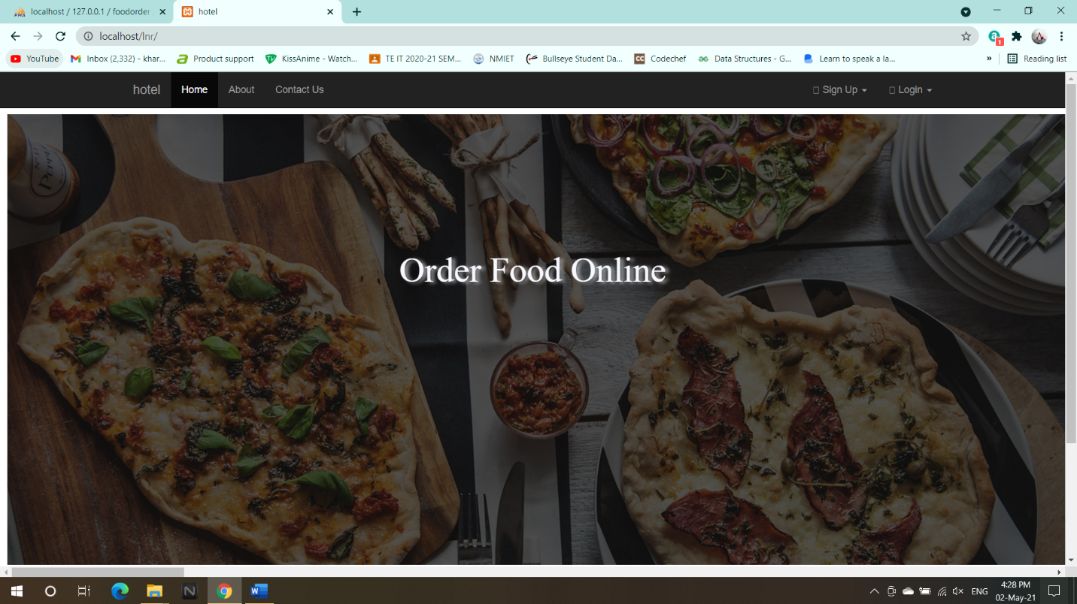

2. Customer Registration Page

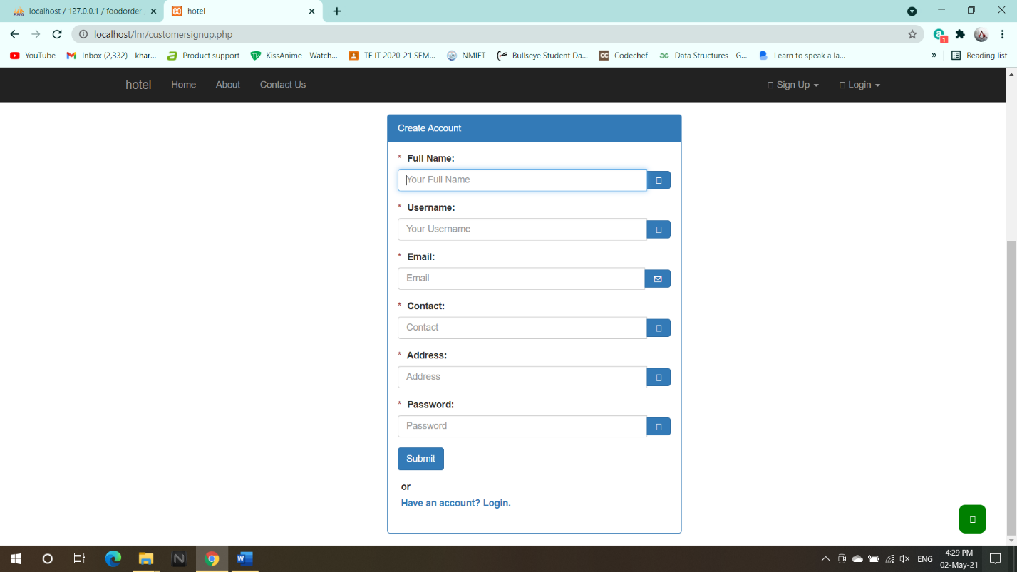

1. Customer Login

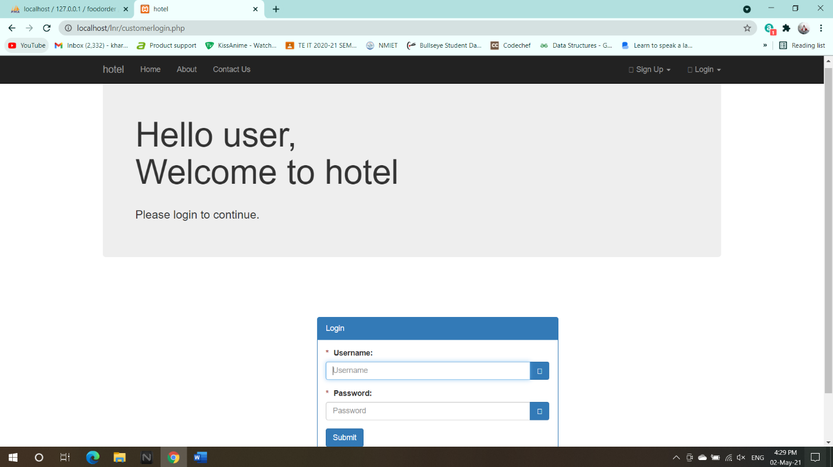

1. Manager Registration

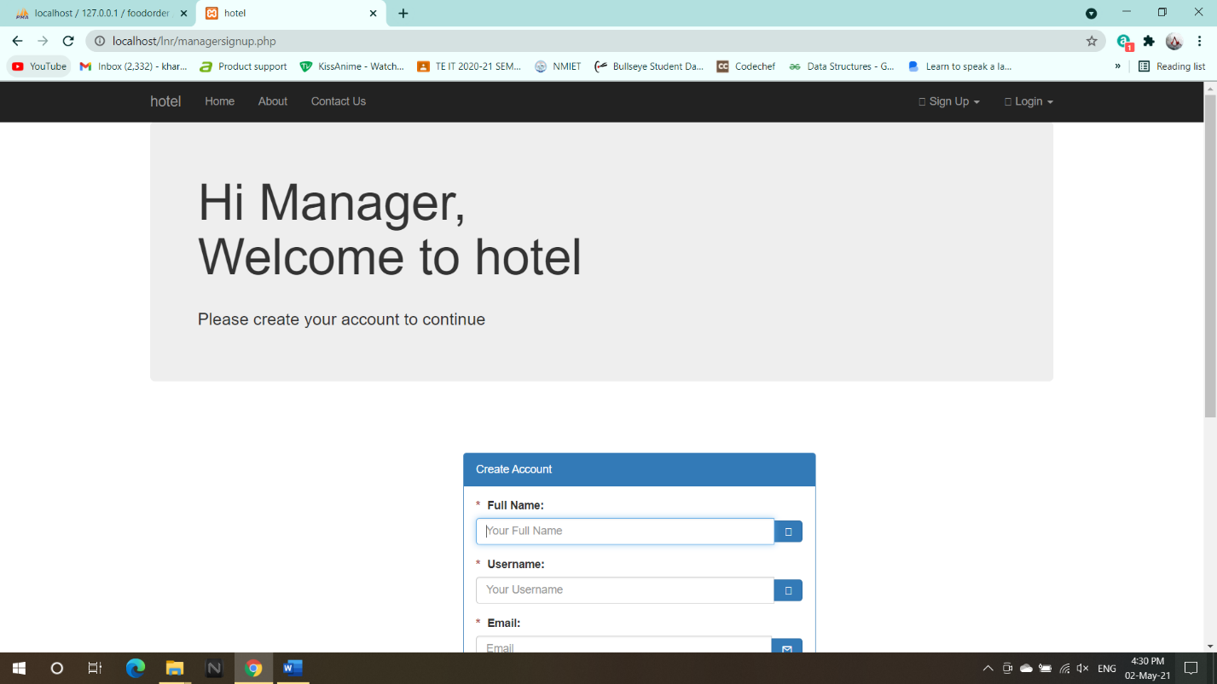

1. Manager Login

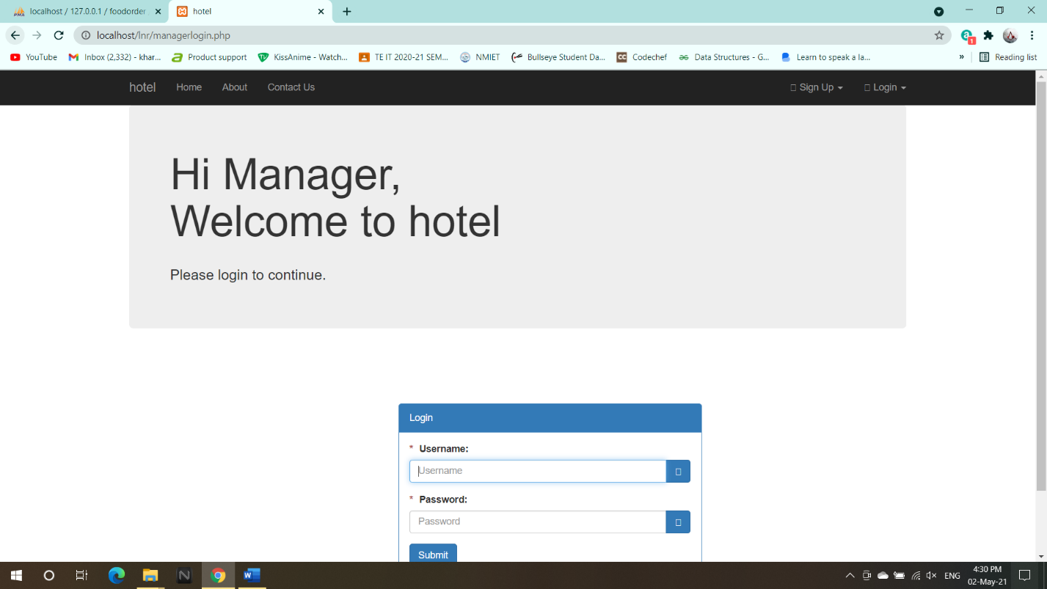

1. Manager Dashboard

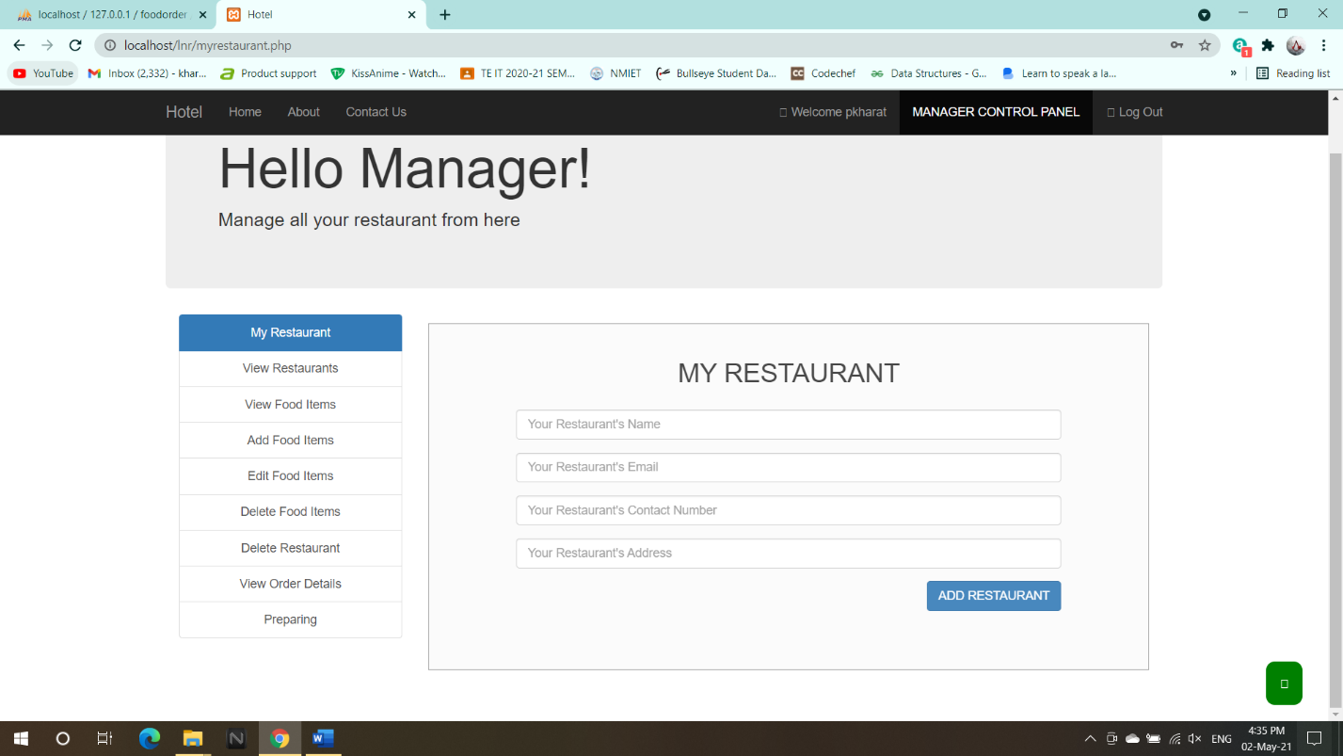

1. Main Restaurant Dashboard

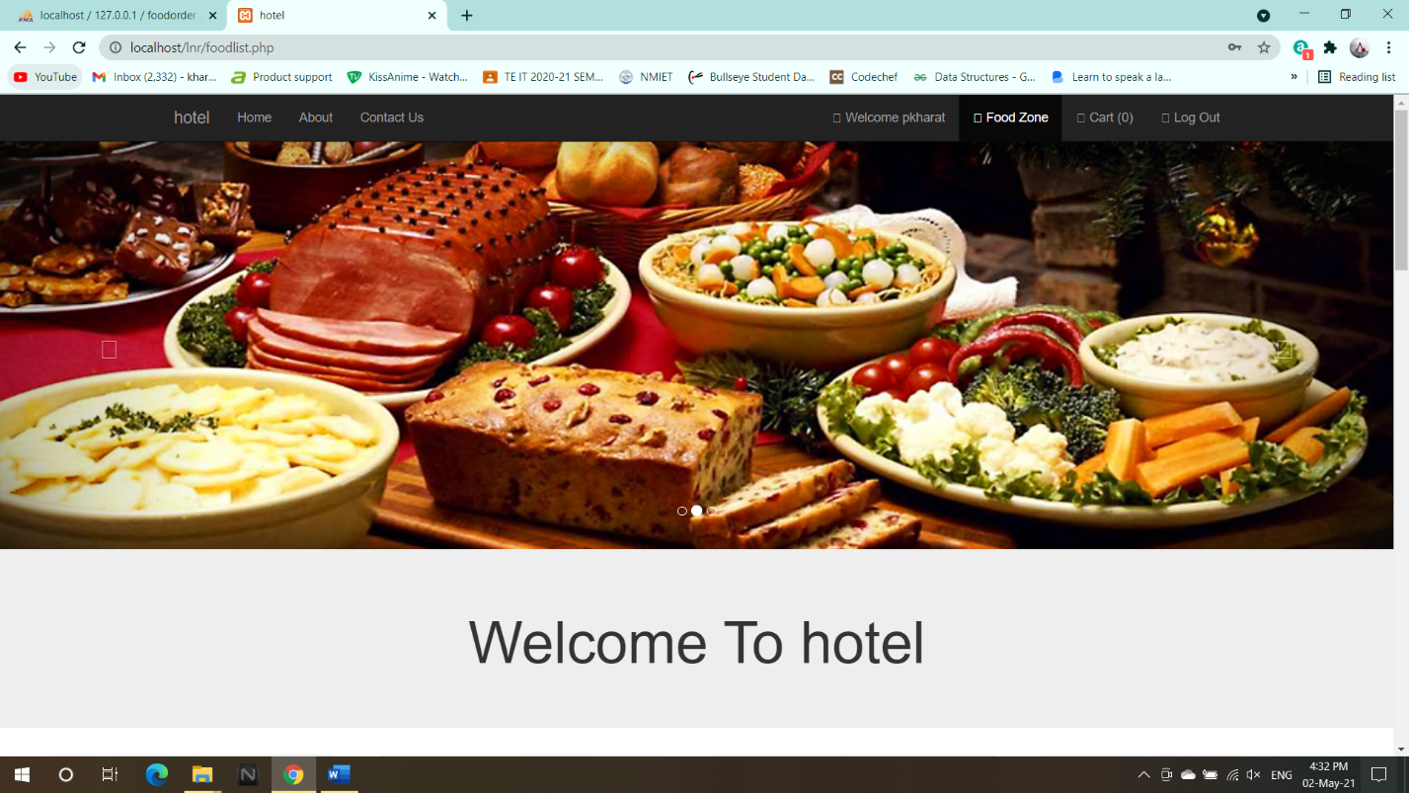

1. About Us

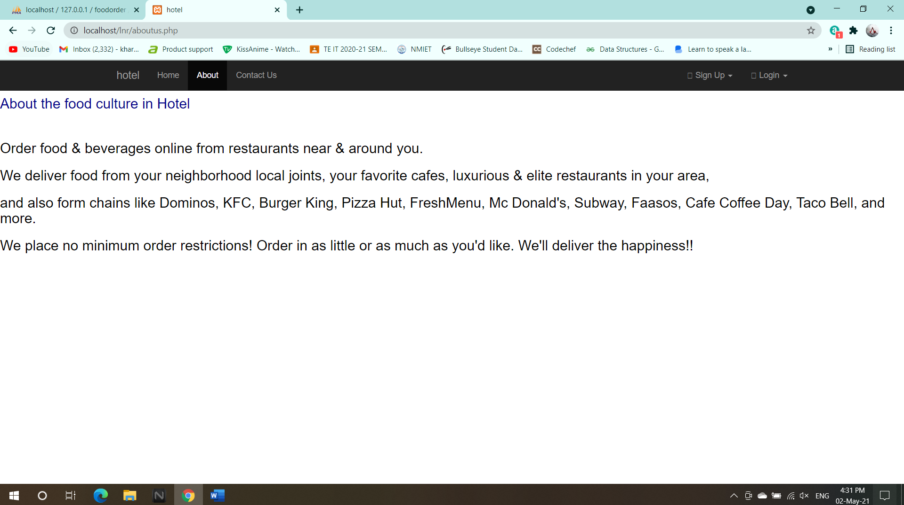

1. Contact Us

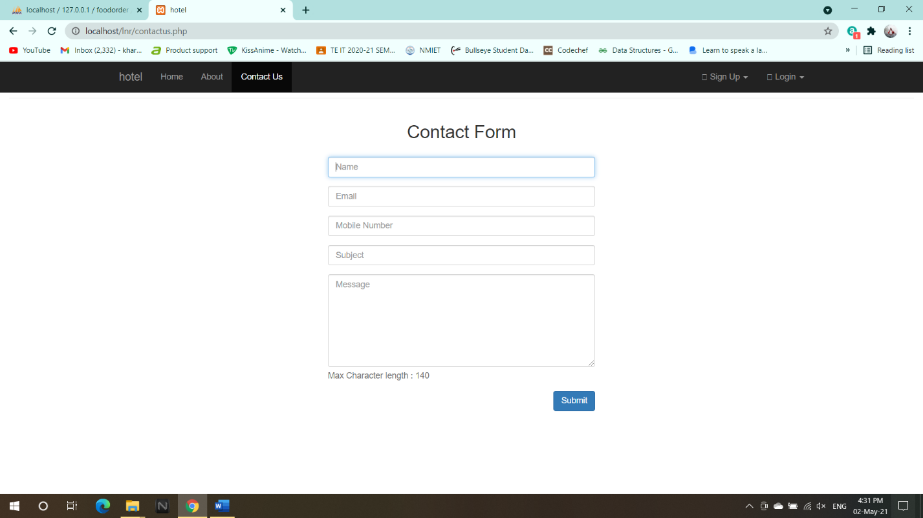

1. Food items on Menu

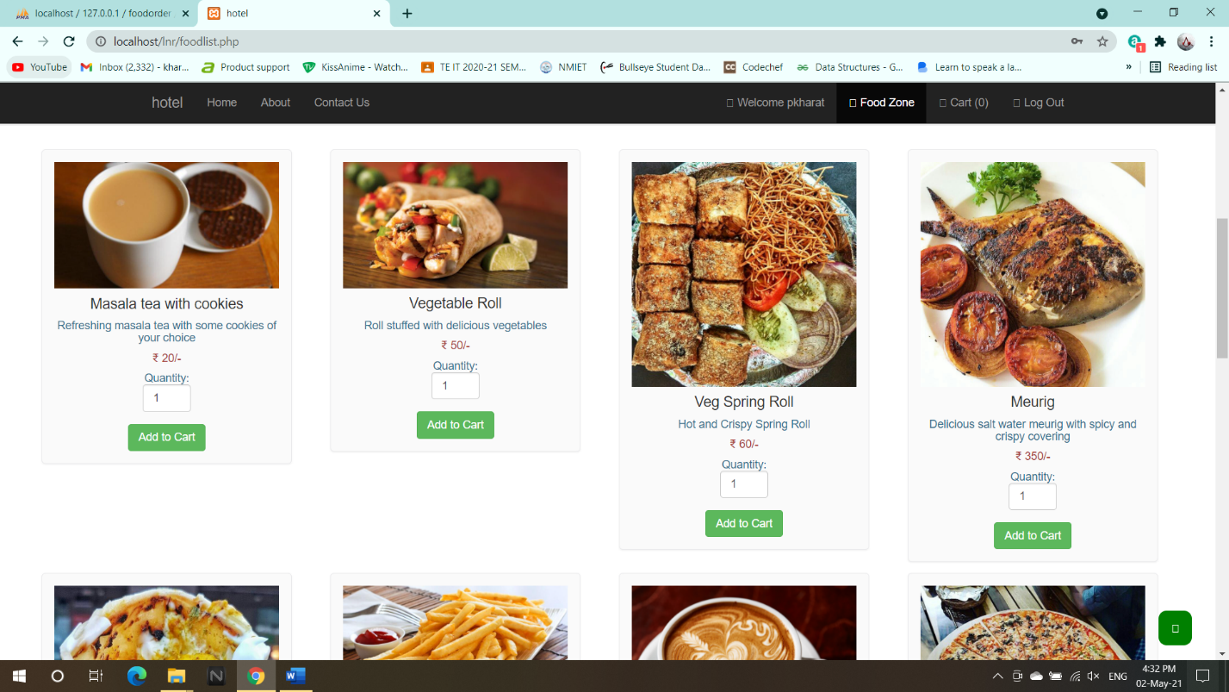

1. Shopping cart

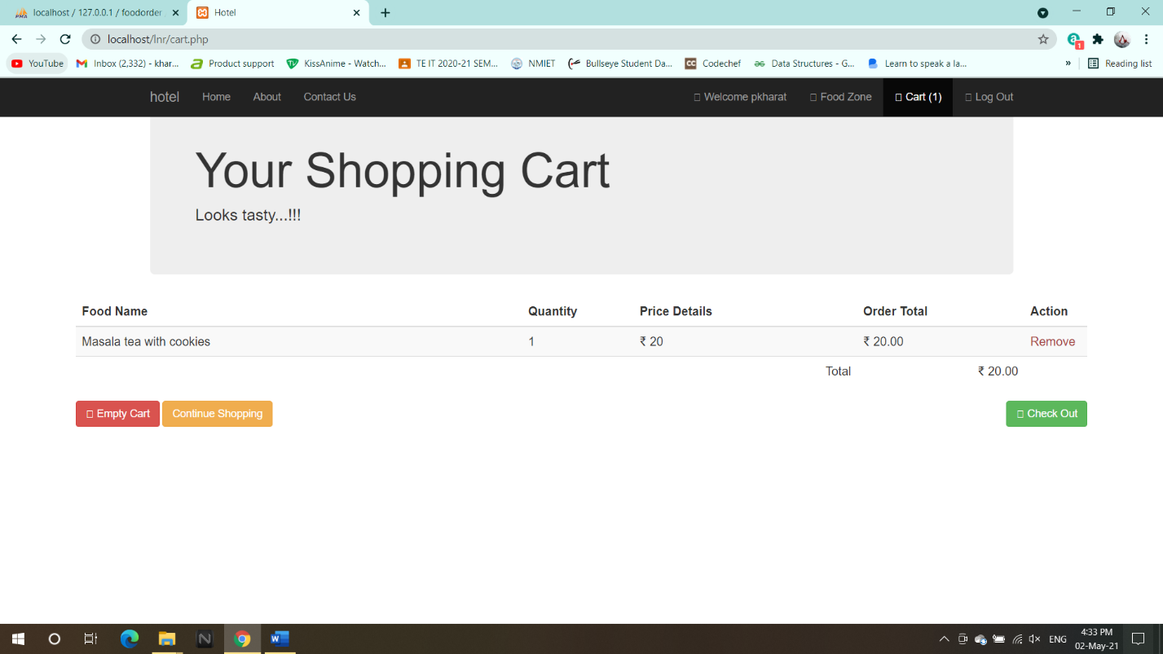

1. Online Payment

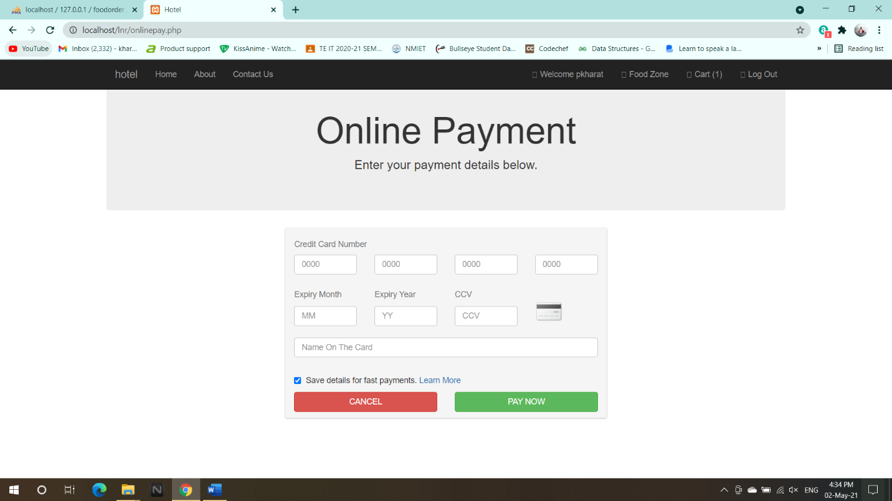

1. Order Placed Successfully

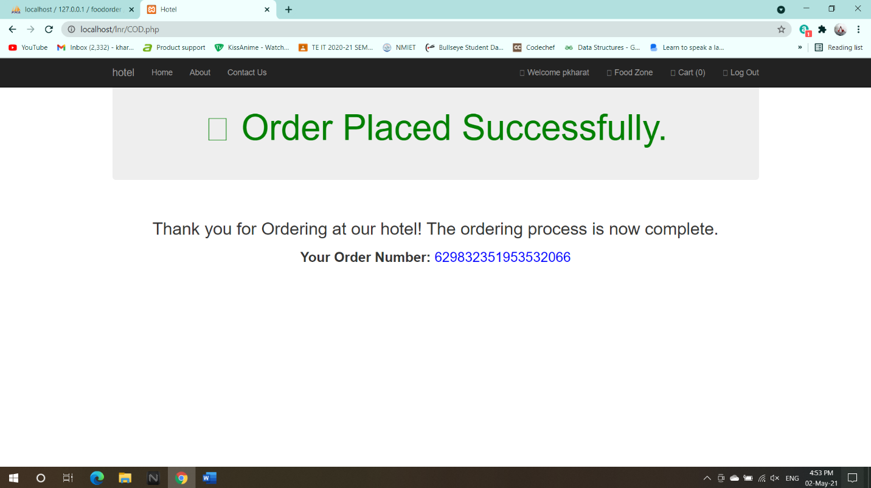

1. Add Restaurant

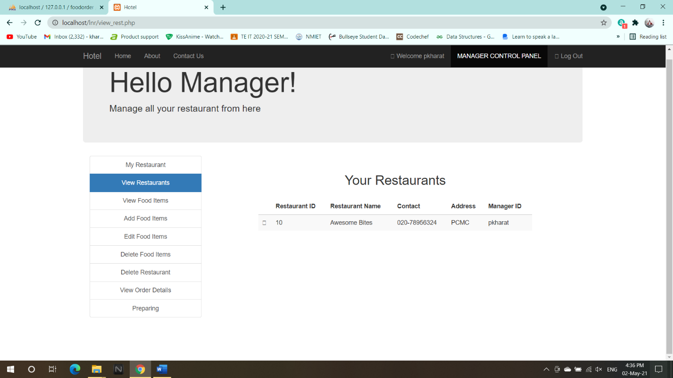

1. Add Food items

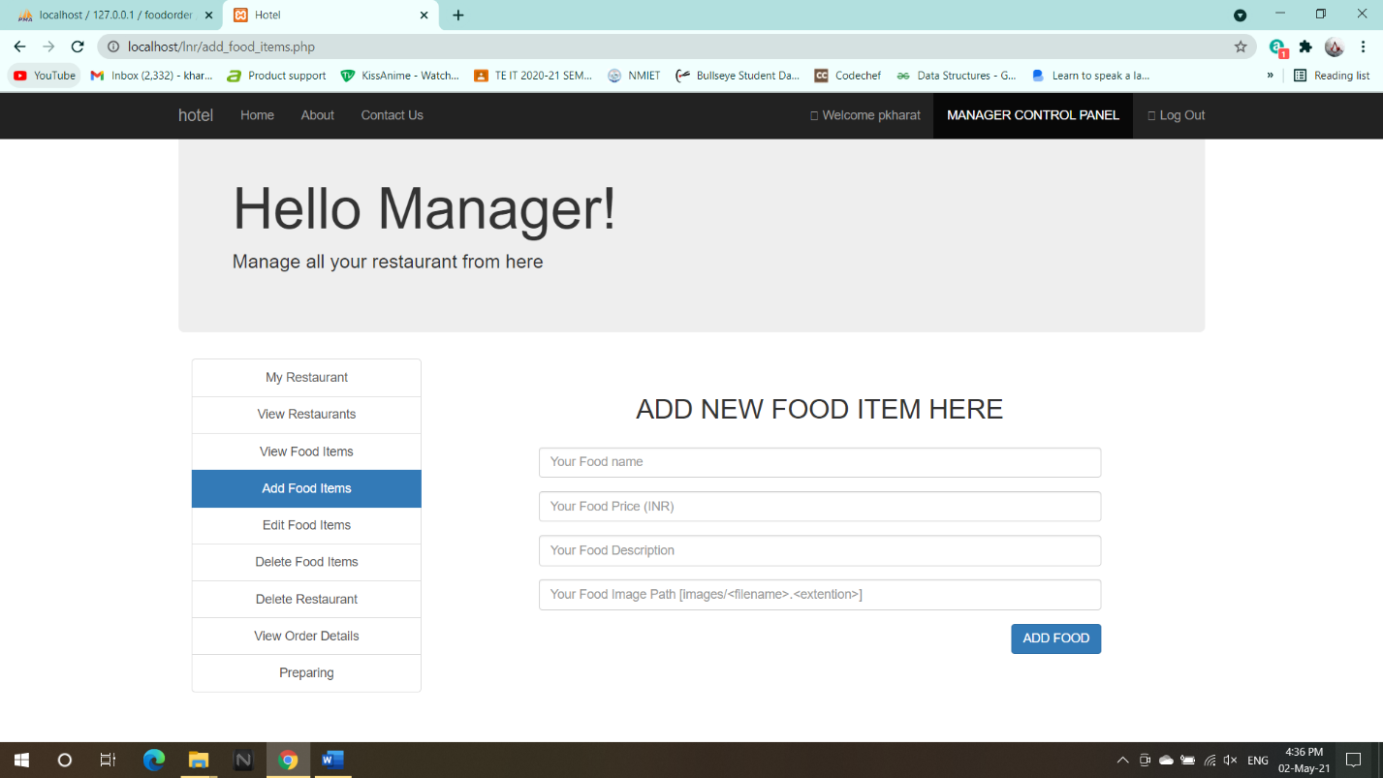

1. Edit Food items

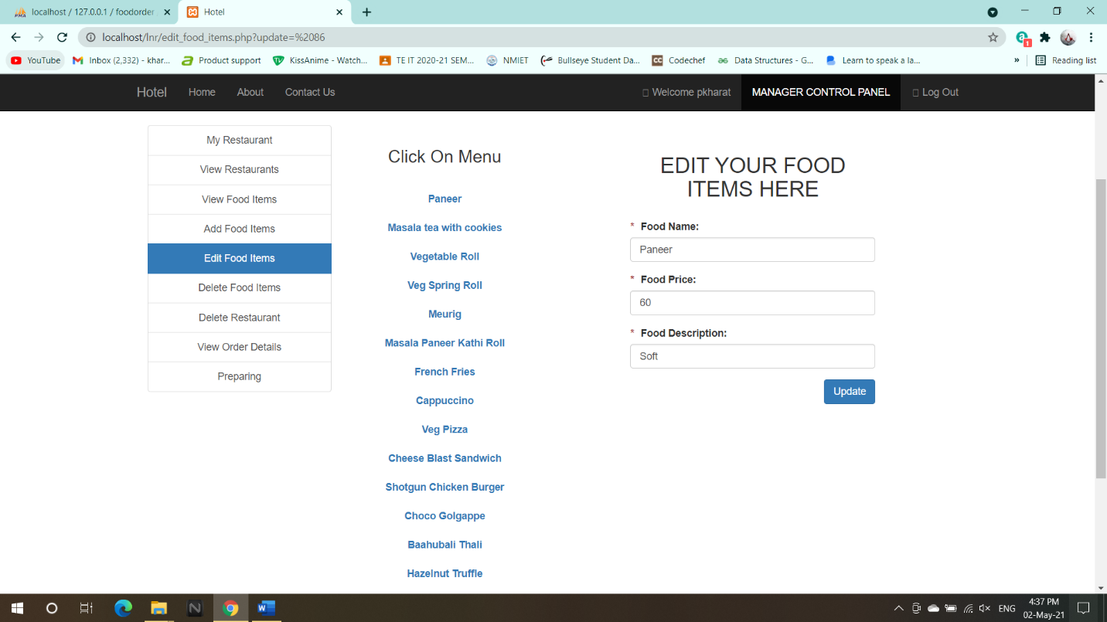

1. Delete food items

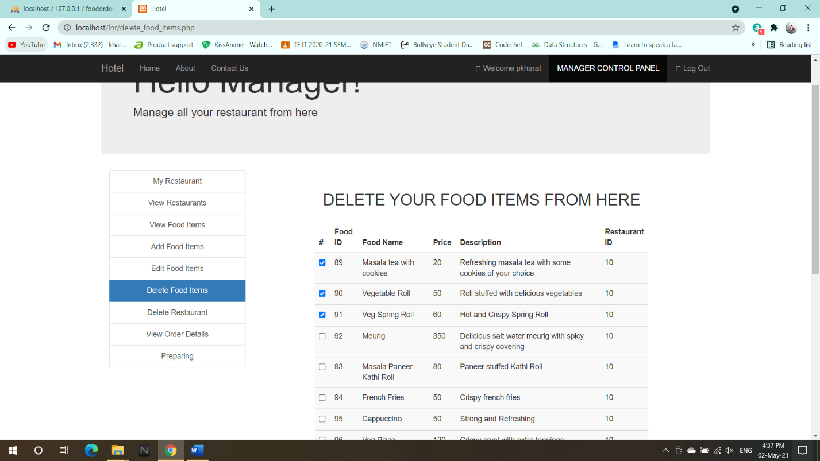

1. Delete Restaurant

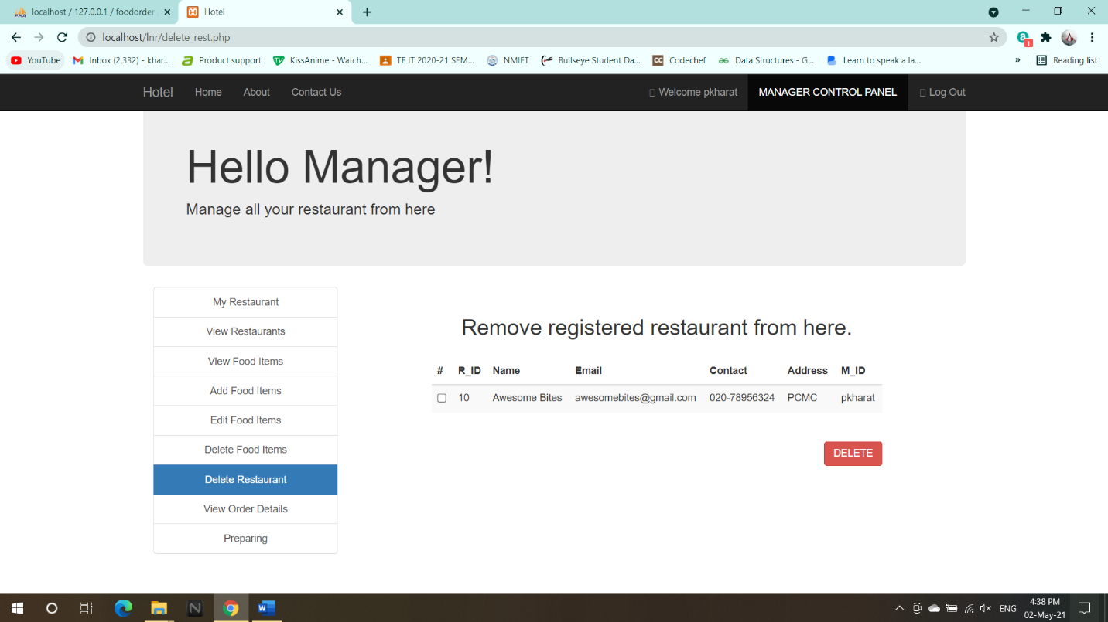

1. Serving

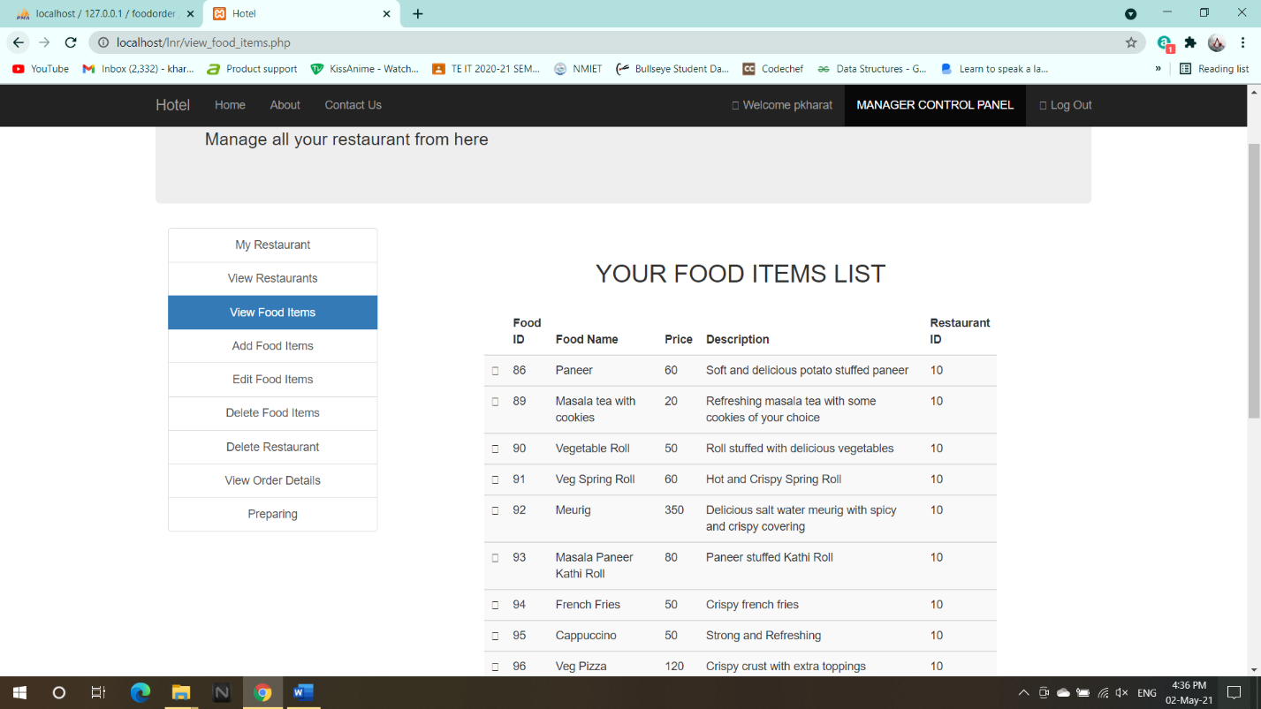

1. In preparation

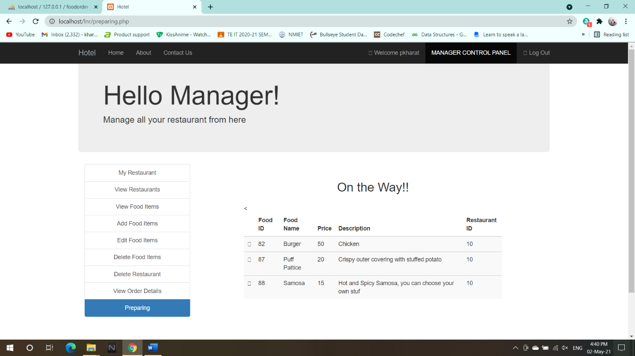

1. Customer Order details

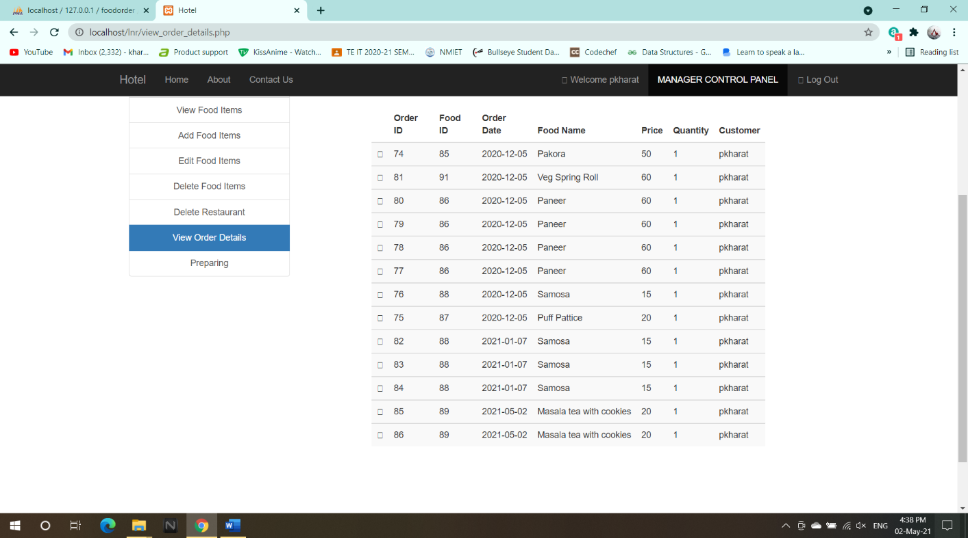

1. Final amount

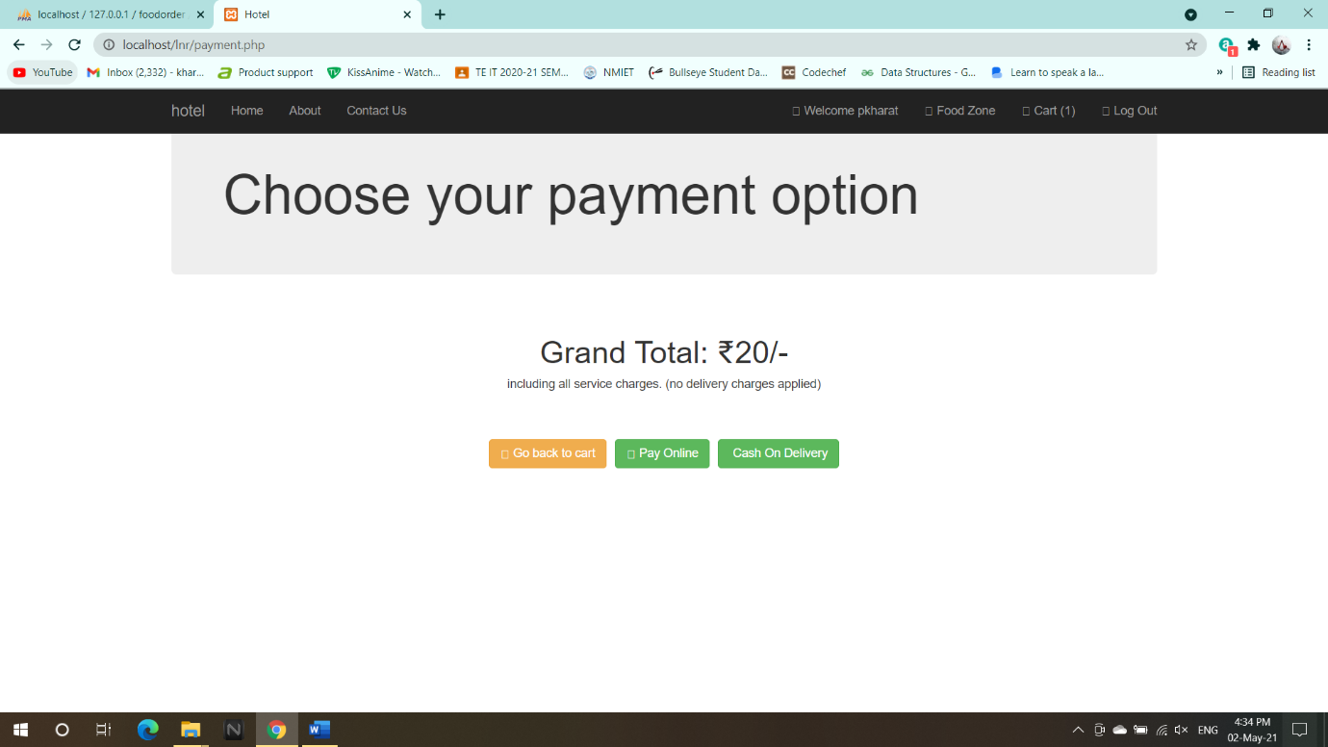

1. Database

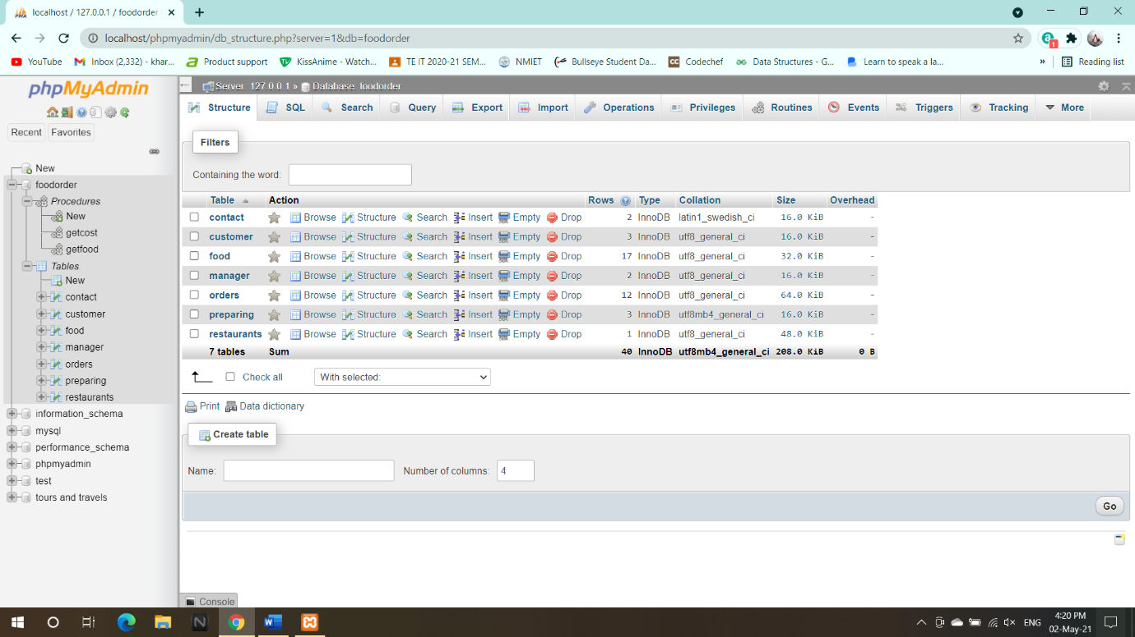

1. Customer list

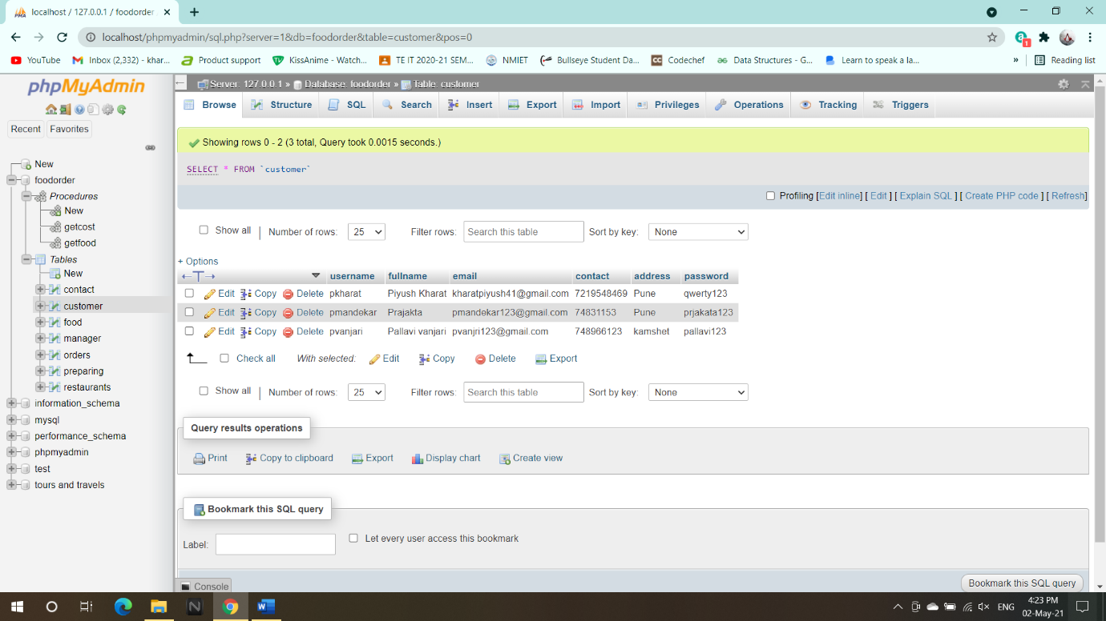

1. Manager list

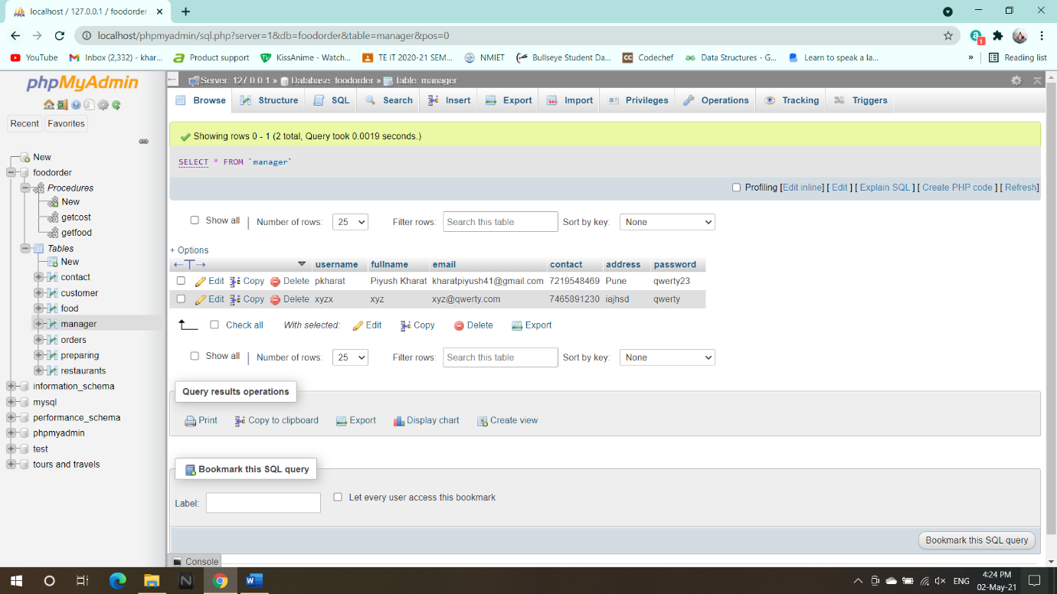

1. Restaurant

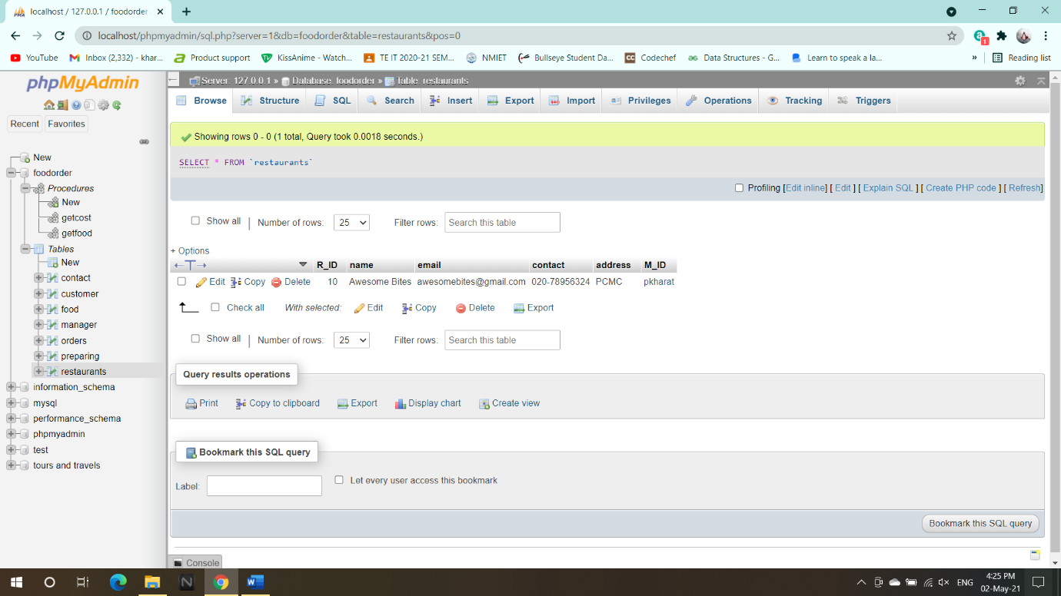

1. Food items

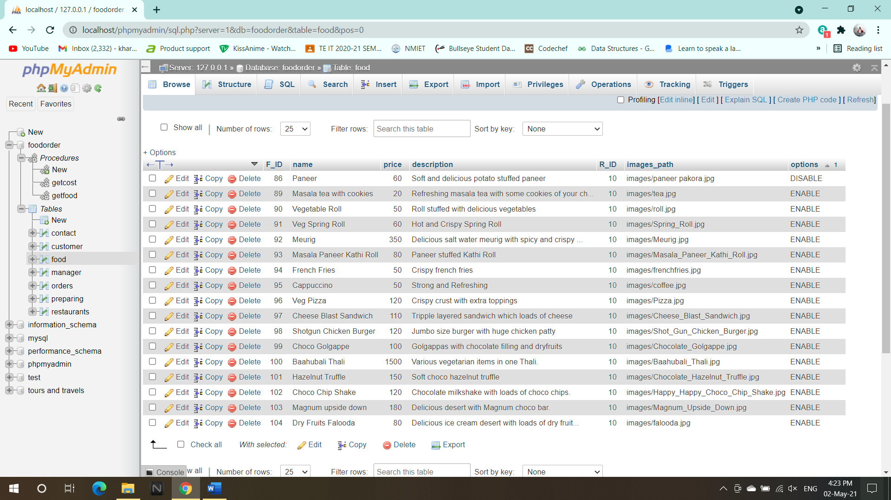

1. Order List

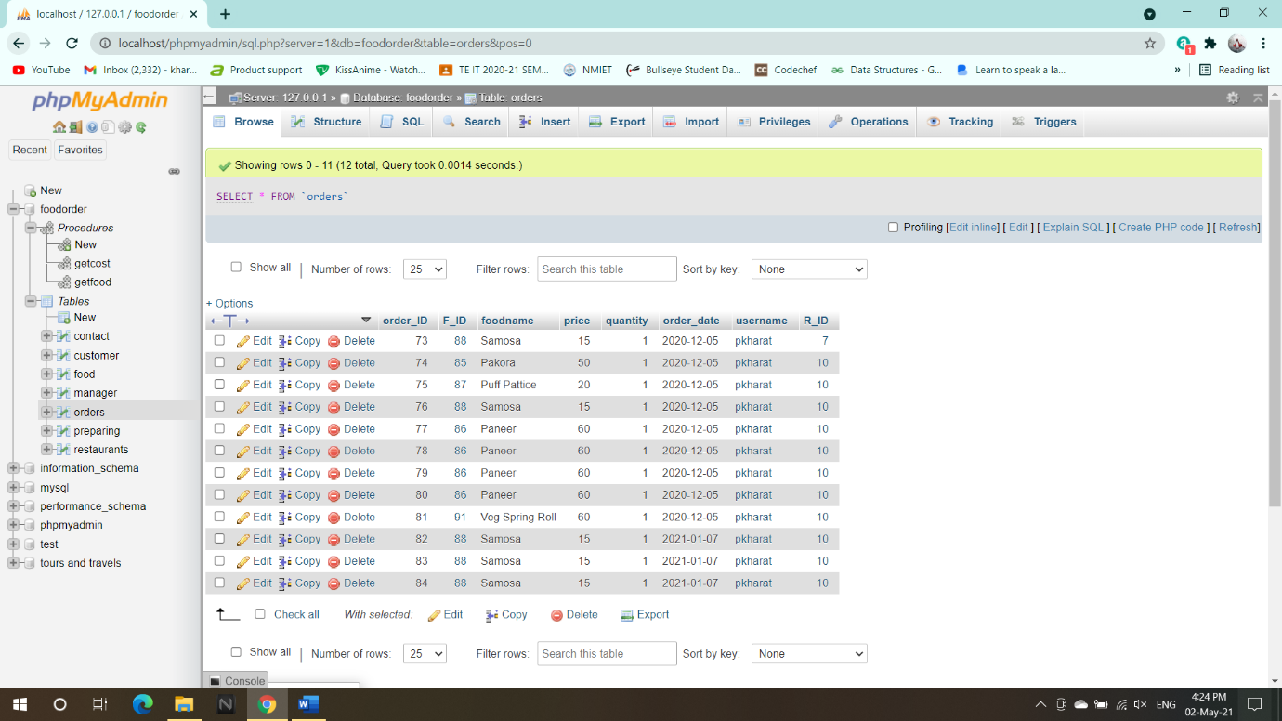

1. Preparing

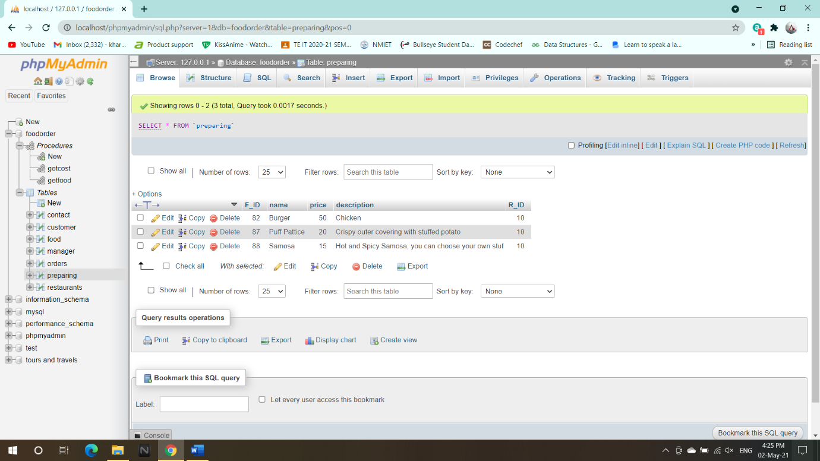

1. Contact us!

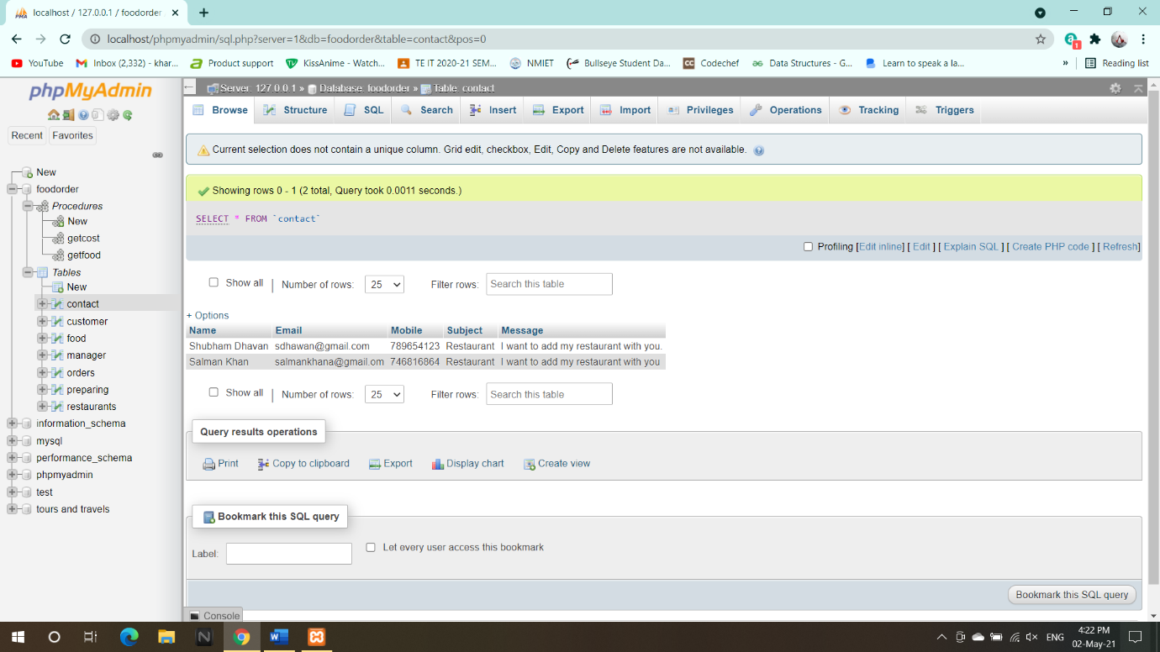

**7.2 CONCLUSION: -**

This online food ordering systems is built for the customers who are dealing with busy lives, this could help them to save some of their time. With private login system customer can place a secure online order and also can view or receive the updates in real-time. It allows the customers to navigate through the menus and customize their orders. Our experience in developing this software was to show the abilities of wireless communication and in refining the business management and decent service delivery.

Generally, the customers who keep on visiting the restaurants are facing problems may be in terms of time, weather, etc. By this application the customer can access their adored food in their place itself. Moreover, this application is useful to all the introverts who hesitate to interact with others. This application does not take much time to order or the delivery of food. It is very simple to use, and it gives an efficient way also.

This designed project is customer friendly and can be used efficiently for storing the customer details, orders, payment options, etc. Thus, this system is user-friendly, convenient and effective so that improves the restaurants performance.

**Chapter 8**

**REFERENCES**

1. Ivan Bayross "Web enabled Commercial Application development using HTML.
2. Dick Oliver and Michael Morrison "HTML and CSS".
3. Steven M. Schafer "HTML, XHTML, CSS".
4. Websites "www.w3schools.com"
5. Websites "www.tutorspoint.com"

